Joint Network Meeting.

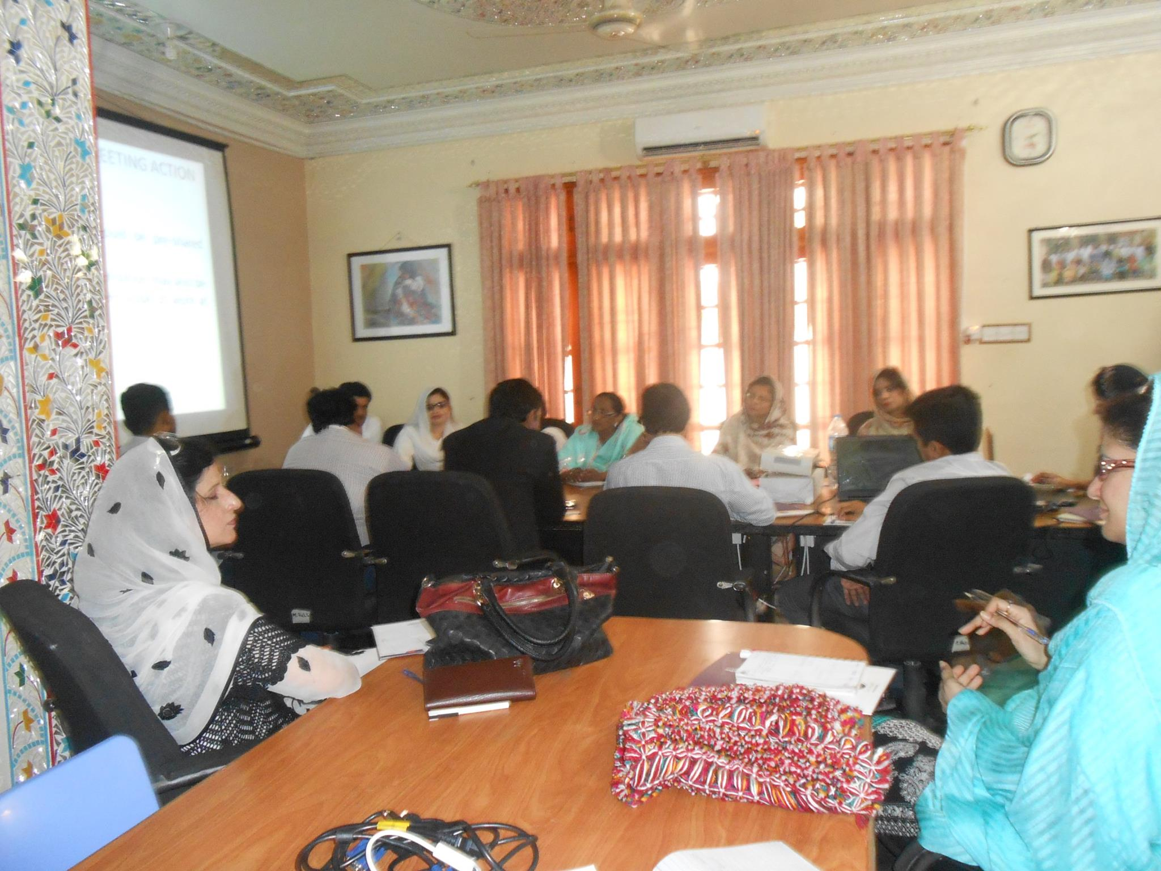

Dastageer Legal Aid Center.

Dated: 19May,2015.

**Farmers Development Organization**

**Agenda**

|  |  |  |  |
| --- | --- | --- | --- |
| S, No | Activity | Time | Responsibility |
| 1 | Progress Update by DLAC | 2:00 to 2:20 PM | Center Coordinator DLAC |
| 2 | Follow-up on Action Points of Previous Meeting | 2:20 to 2:40 PM | Discussion |
| 3 | Recommendations for Justice Cluster/ Network | 2:40 to 3:10 PM | Discussion |
| 4 | ToRs/ Mechanism for Justice Cluster Multan | 3:10 to 3:40 PM | Discussion |
| 5 | Action Points for future meetings | 3:40 to 3:55 PM | Discussion |
| 6 | Any Other Point | 3:55 to 4:00 PM | Discussion |
| 7 | Refreshment | 4:00 PM |  |

**Objective:**

* To build a platform for vulnerable population & to assure sustainability of Dastageer Center.
* To strengthen the referral Mechanism.
* Build the Capacity of Dastageer Legal Aid Center.
* To build the linkages with other organizations and lobbying.
* Strong coordination.
* Improved knowledge of & positive behaviors among local Government departments towards fundamental rights of vulnerable community.
* To Support Dastgeer center advocacy on human rights frame work especially focusing on GBV, Minorities, PWDs & ethic rights.

**Proceedings:**

Joint network Meeting was started with the name of Allah and then all the participants introduced their self. Miss Rubina reviewed the project objective and scope & shared the progress of Dastageer center.

|  |  |  |
| --- | --- | --- |
| **Sr #** | **Target** | **Achievements** |
| **1** | **Court cases** | **8** |
| **2** | **Legal Assistance** | **2** |
| **3** | **Walk in Beneficiaries** | **119** |
| **4** | **Incoming calls** | **90** |
| **5** | **Referred Cases to other Departments** | **15** |

She also paid honor & thanks to the organizations for facilitating the referred clients. She also thanks to stake holders of right based organizations for the timely identification and resolution of prevalent issues within the communities by cooperating with Dastageer legal Aid Center. She discuss development plans and their execution on both community level through lobbying and linkages development and on government level by approaching the government line department.

She talked about the recommendations to form the Justice Cluster/ Network & asked to participate the all participants of organization. All partners actively participate & share their Views & concerns regarding cluster formation. They also appreciated the courage of Dastgeer center to build a cluster of justice.

After the recommendations, the concerns of the participants of organization members were following.

1. District legal Aid committees & their role?
2. Are project services limited?
3. How we can assure project sustainability?
4. Who will be responsible/look after this network after project end?
5. How this mechanism assure free legal aid after project end?
6. Is there any strong mechanism to make assure visibility and advertisement through media like TV, F.M & news bulletin?

Answers of these questions and views to resolve issues given by Khuram, Waqas & Rubina.

Participants gave their feedback about the knowledge of message and described their views and ideas. Message afterward shaped in form of linkages development through resource mobilization.

Following action points are made by the Participants.

**Action points.**

* Every organization would share their one page profile regarding their objective, area of interest & scope.
* By sharing profile of each organization we would move one step forward to build strong network.
* Coordination with other organization should be strong.
* Demand for legal Aid services among vulnerable group through this coordination should be increased.
* Knowledge & positive behaviors among local Government departments towards fundamental rights of vulnerable community would be assured.
* Right based organizations would be served as liaison between legal Aid Center & Community.
* Assurance to refer victims to Dastgeer center.

At the end Miss Rubina thanks to all for their participation, coordination & to take step for justice cluster formation.